ASSIGNMENT 7.2

Write a program to implement wordcount using Pig.

EXAMPLE:

SAMPLE INPUT:” this is the hadoop programming where this programming is related to apache

Hadoop”

SAMPLE OUTPUT:(is,2)

(to,1)

(the,1)

(this,2)

(apache,1)

(hadoop ,2)

(related,1)

(programming,2)

STEP 1: load the relation named “rel” and data into it.

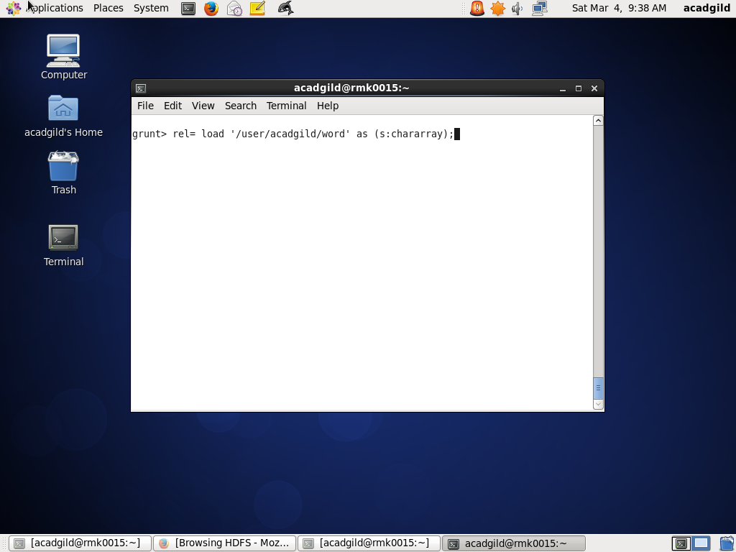

STEP 2: Dump the data should be performed.

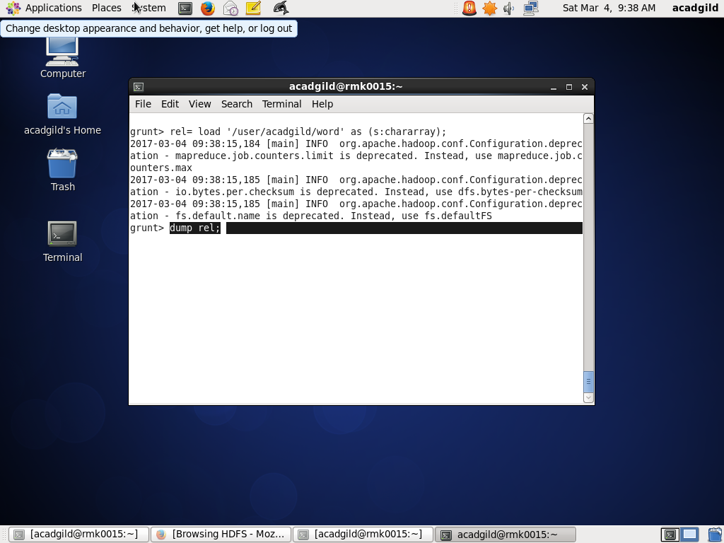

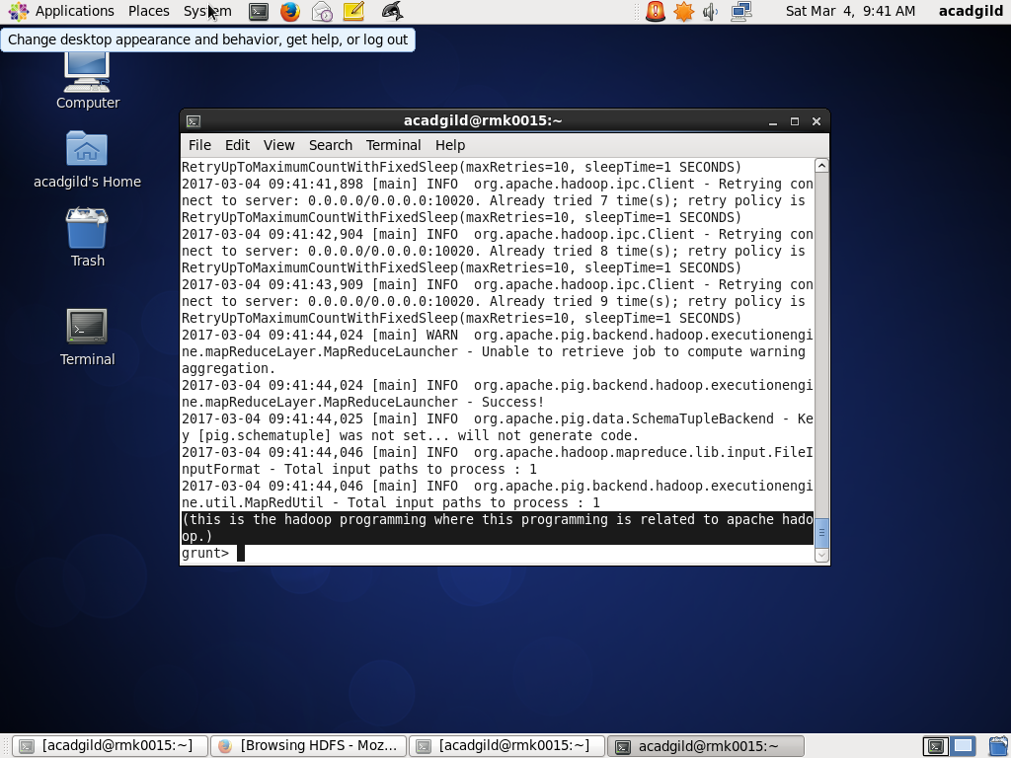

STEP 3: Use of flatten n tokenize commands on relation that has been loaded.

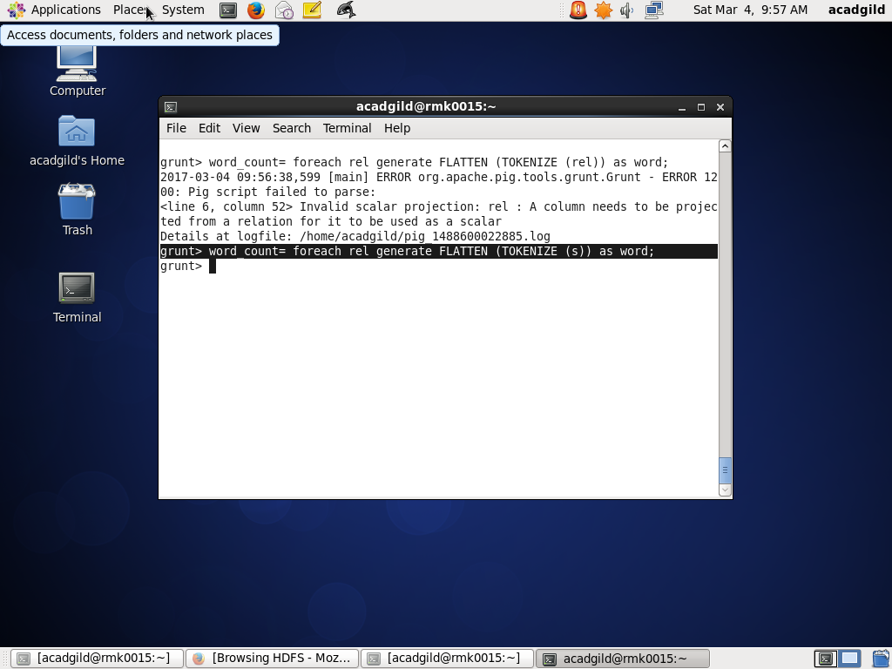

STEP 4: Grouping and then counting the words present in the data provided.

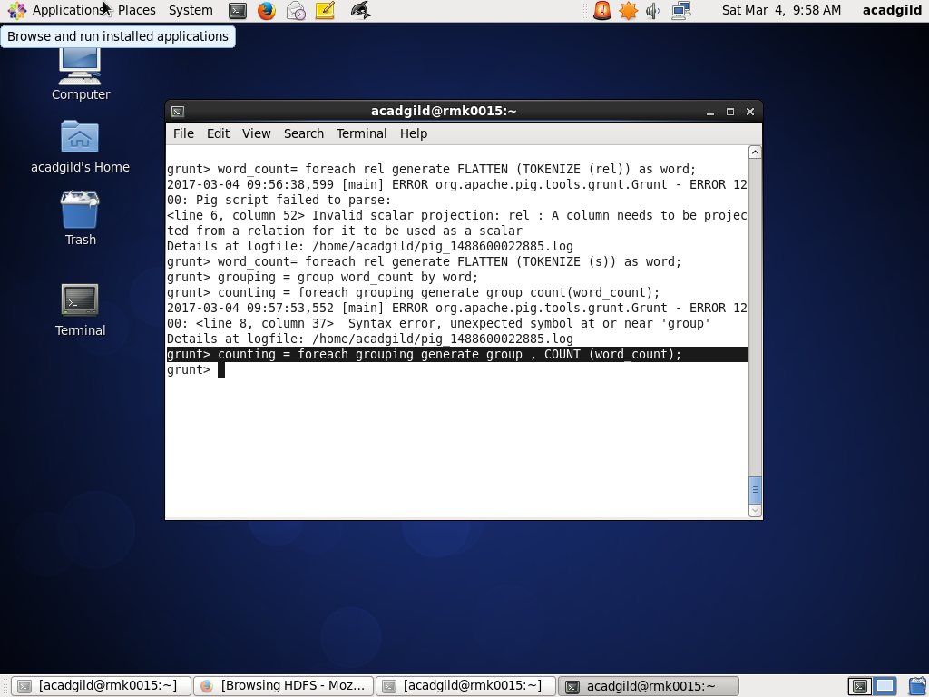

Step 5: After dumping the required output obtained

